
Affiliated to University of Mumbai 2026 – 2027

SUBJECT GUIDE
AMIT PANDEY
(Asst. Professor)

SUBMITTED BY:
SADHANA RAOSAHEB GADAKH
ROLL NO: 264416

SUBMITTED IN PARTIAL FULFILLMENT OF THE
REQUIREMENTS

FOR QUALIFYING M. Sc.IT PART I
(SEMESTER I EXAMINATION)

CERTIFICATE OF APPROVAL

This is to certify that Ms. Sadhana Raosaheb Gadakh student of “Master of Science (Information Technology)” of “Thakur College of Science and Commerce”. Roll No. 264416 has successfully completed and submitted the Practical & Assignment entitled “Research in Computing” in the partial fulfilment as per the syllabus defined by the University of Mumbai in the academic year 2026 2027.

It is further certified that the student has completed all the required phases of the practical & assignment.

__________________________
HEAD OF DEPARTMENT

_________________________ ________________________
PROFESSOR INCHARGE EXTERNAL EXAMINER

INDEX


PRACTICAL NO. 1
Practical 1: A) W.a.p create and save the pie chart in the current R working directory
Theory:
R Programming language has numerous libraries to create charts and graphs. A pie-chart is a representation of values as slices of a circle with different colors. The slices are labeled and the numbers corresponding to each slice is also represented in the chart. In R the pie chart is created using the pie() function which takes positive numbers as a vector input. The additional parameters are used to control labels, color, title etc.
The basic syntax for creating a pie-chart using the R is − pie(x, labels, radius, main, col, clockwise)

CODE :
x <- c(21, 62, 10, 53)
labels <- c("London", "New York", "Singapore", "Mumbai")
png(file = "city_title_colours.jpg")
pie(x, labels, main = "City pie chart", col = rainbow(length(x)))
dev.off()

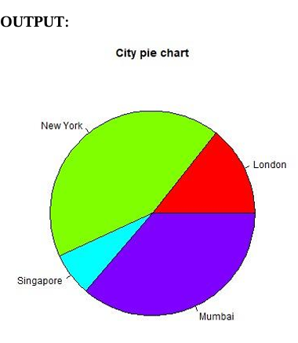
B) Create a Data Frame on the basis of this data:
X=21, 62, 10, 53
Y="London", "New York", "Singapore", "Mumbai"
Theory:
A data frame is a table or a two-dimensional array-like structure in which each column contains values of one variable and each row contains one set of values from each column.
Following are the characteristics of a data frame.
● The column names should be non-empty.
● The row names should be unique.
● The data stored in a data frame can be of numeric, factor or character type.
● Each column should contain a same number of data items.
CODE :
#Create data for the graph.
x <- c(21, 62, 10, 53)
labels <- c("London", "New York", "Singapore", "Mumbai")
png(file = "city_title_colours.jpg")
pie(x, labels, main = "City pie chart", col = rainbow(length(x)))
#Save the file. dev.off()
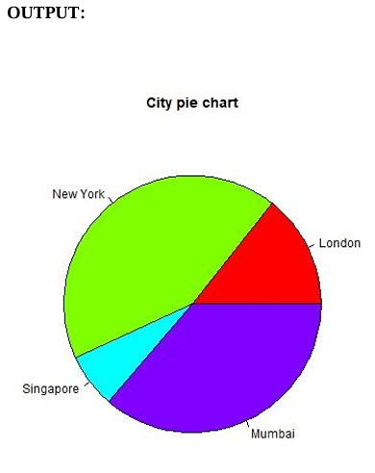
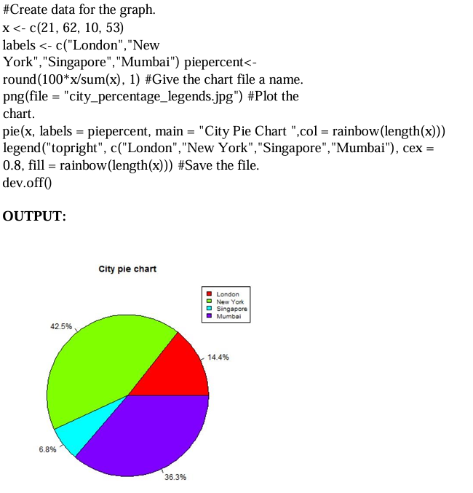
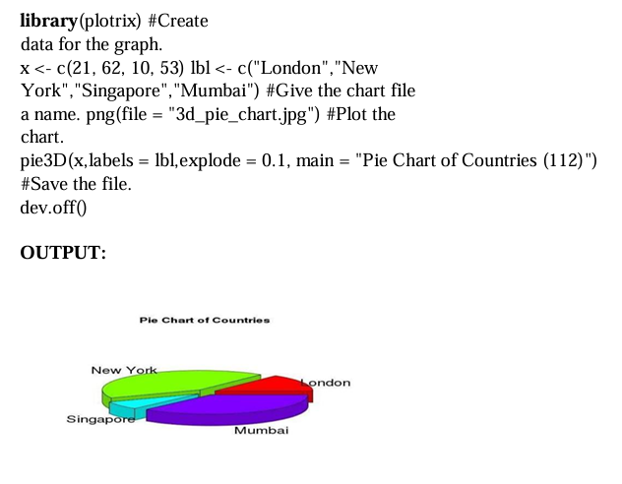
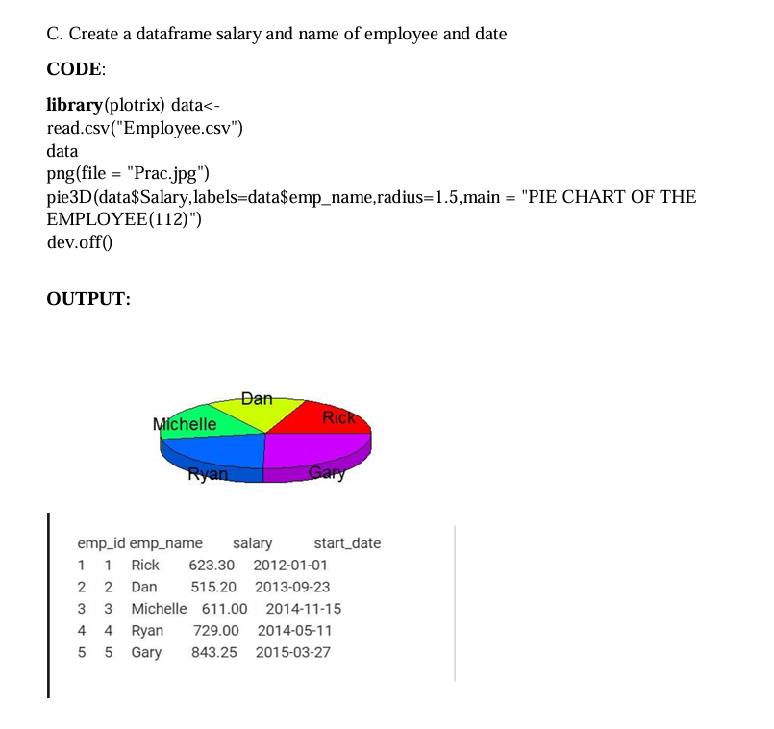

PRACTICAL NO. 2
Practical 2: Perform program based on dataframe/csv operation
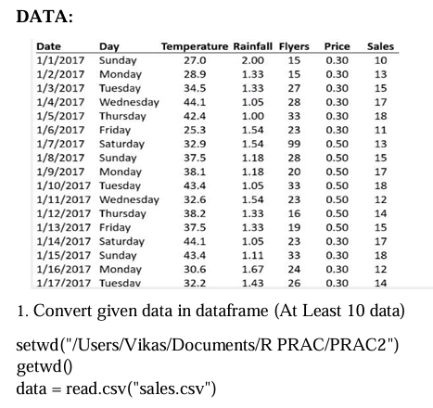
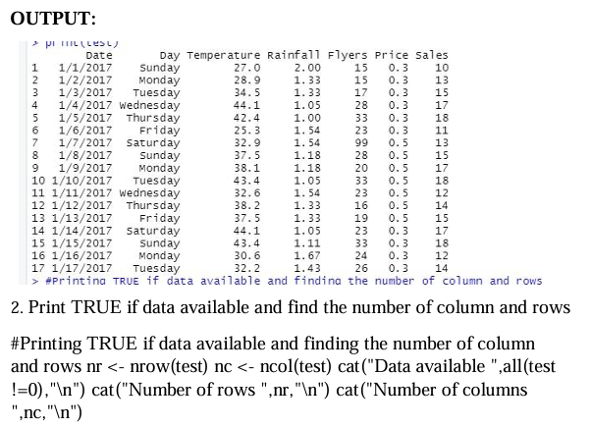
OUTPUT:
Data available TRUE
Number of rows 17
Number of columns 7
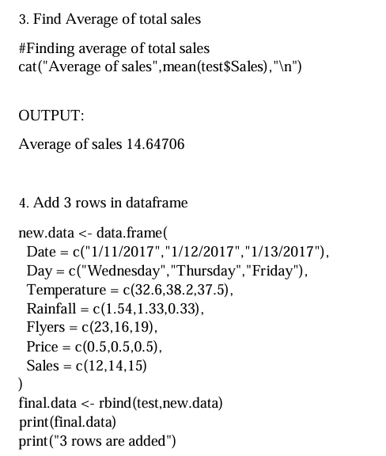
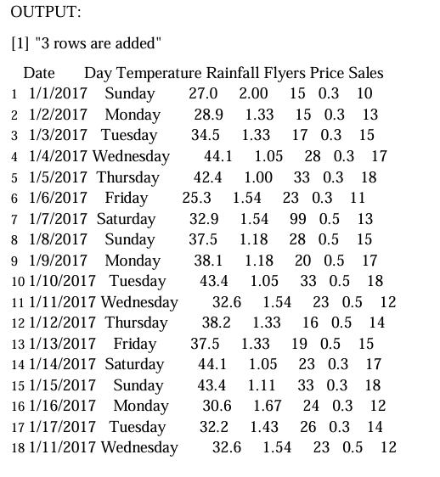
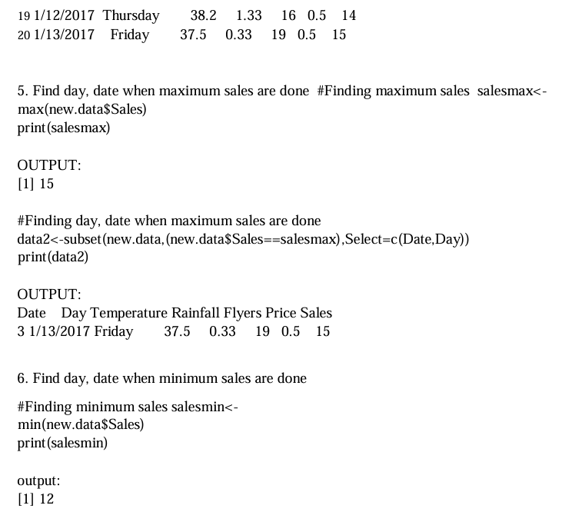
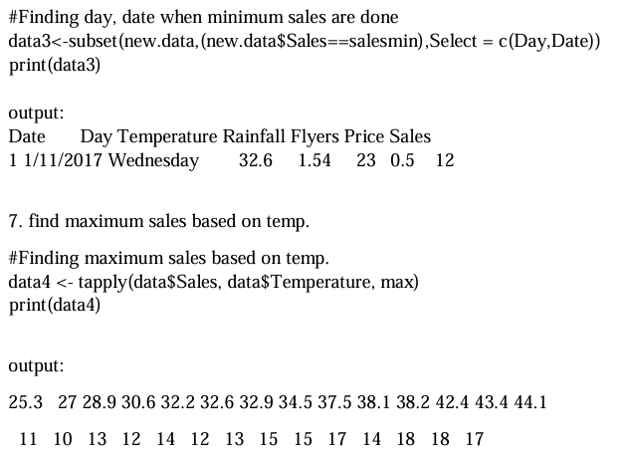

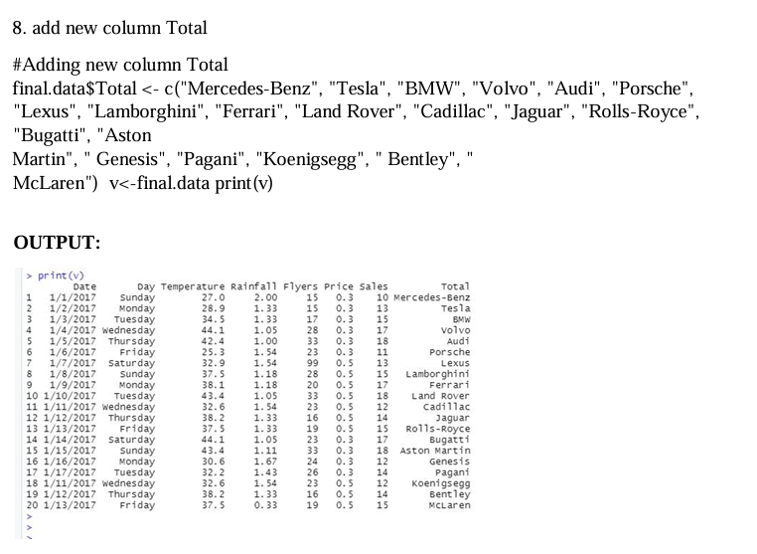

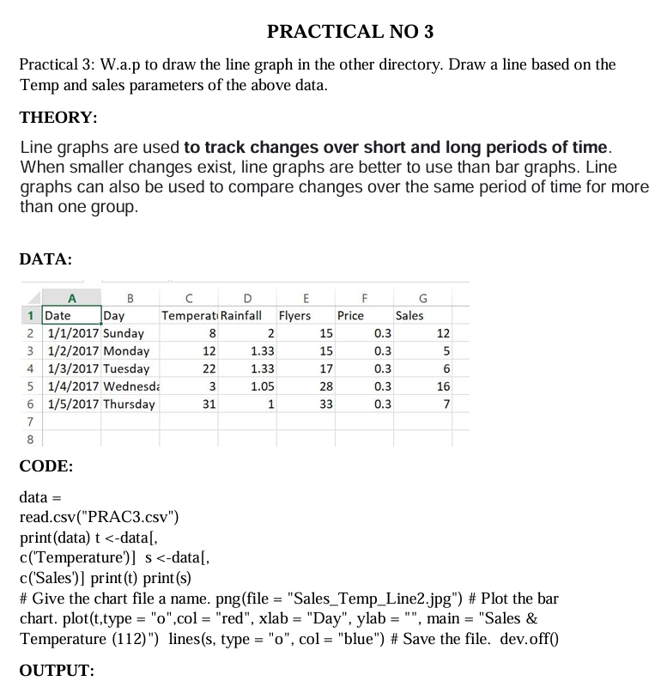
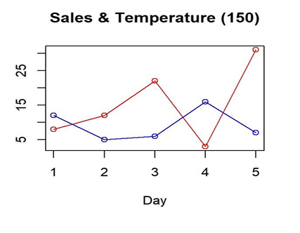
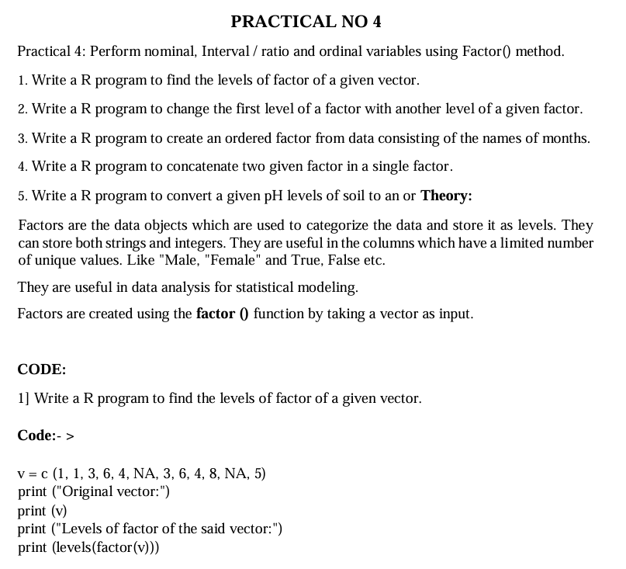
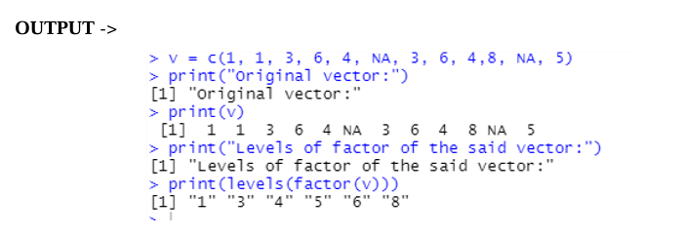

2] Write a R program to change the first level of a factor with another level of a given factor.
